RF Waveform Generator

Brian Chau

Daniel Hickl

Eugene Asare

Khoi Le

**Subsystem Reports**

Subsystem Reports

for

RF Waveform Generator

Prepared by:

_____________________________

Author Date

Approved by:

_____________________________

Project Leader Date

_____________________________

John Lusher, P.E. Date

_____________________________

T/A Date

**Change Record**

| **Rev.** | **Date** | **Originator** | **Approvals** | **Description** |
| --- | --- | --- | --- | --- |
| **-** | 04/25/24 | RF Waveform Generator |  | Draft Release |
| **1** | 04/27/24 | RF Waveform Generator |  | Final Report - ECEN 403 |
| **2** | 11/24/24 | RF Waveform Generator |  | Final Report - ECEN 404 |

**Table of Contents**

**1. Introduction 6**

**2. Power Distribution Subsystem Report 7**

2.1. Subsystem Introduction 7

2.2. Subsystem Details 7

2.2.1. System Function 7

2.2.2. Schematics, PCB Layout, and Assembly 8

2.3. Subsystem Validation 9

2.4. Subsystem Conclusion 13

**3. Analog Drive Subsystem Report 13**

3.1. Subsystem Introduction 13

3.2. Subsystem Details 13

3.2.1. System Function 13

3.2.2. Schematics, PCB Layout, and Assembly 14

3.3. Subsystem Validation 16

3.3.1. Validation Overview 16

3.3.2. Validation Tests 16

3.4. Subsystem Conclusion 22

**4. VCO/ RF Amplifier Subsystem Report 22**

4.1. Subsystem Introduction 22

4.2. Subsystem Details 22

4.2.1. System Function 22

4.2.2. Schematics and PCB Design Layout 23

4.3. Subsystem Validation 23

4.3.1. Validation Plan 23

4.3.2. Test Results 24

4.3.3. Analysis and Observations 26

**5. Testing Board Subsystem Report 28**

5.1. Subsystem Introduction 28

5.2. Subsystem Details

5.2.1. System Function 28

5.2.2. Simulation Result 28

5.2.3. Subsystem Schematic and PCB Layout 29

5.3. Subsystem Validation 31

5.3.1. Validation Plan 31

5.3.2. Testing Mixer Result 32

**6. Support Requirements 34**

**Appendix A: Acronyms and Abbreviations 35**

**Appendix B: Definition of Terms 36**

**List of Tables**

**Table** **1. Power Distribution Rail Breakdown** **7**

**Table 2. Voltage Testing****11**

**Table 3. Power Monitor Test****12**

**Table 4. Constant Voltage Mode Tests 16**

**Table 5. 1kHz Modulation Mode Tests 17**

**Table 6. 5kHz Modulation Mode Tests 17**

**Table 7. 10kHz Modulation Mode Tests 17**

**Table 8. VCO and RF Amp Validation Tests 23**

**Table 9. Testing Result for Reference 29**

**Table 10. Validation Plan for Testing Board Subsystem 31**

**List of Figures**

**Figure 1. Sub-System Overview** **1**

**Figure 2. Power Distribution Schematic** **8**

**Figure 3. Power Distribution PCB Design Layout** **8**

**Figure 4. Power distribution Final PCB** **9**

**Figure 5. Op Amp Rail No Load Test** **10**

**Figure 6. Op Amp Rail with Load Test** **10**

**Figure 7. Digital Rail LDO Test** **10**

**Figure 8. VCO Rail LDO Test** **10**

**Figure 9. Power Monitor Signal Test** **12**

**Figure 10. MCU Design** **14**

**Figure 11. MCU Schematic** **14**

**Figure 12. MCU Layout** **15**

**Figure 13. MCU Assembly** **15**

**Figure 14. 1kHz Modulation Mode** **18**

**Figure 15. 5kHz Modulation Mode** **19**

**Figure 16. 10kHz Modulation Mode** **19**

**Figure 17. UART Connection 20**

**Figure 18. I2C Connection 20**

**Figure 19. VCO and RF Amp Schematic 22**

**Figure 20. VCO PCB Design Layout 22**

**Figure 21. VCO Final PCB 22**

**Figure 22. 0V DC Tuning Voltage 23**

**Figure 23. 10V DC Tuning Voltage 2****3**

**Figure 24. 13V DC Tuning Voltage 24**

**Figure 25. 1kHz AC Tuning Voltage 24**

**Figure 26. 5kHz AC Tuning Voltage 24**

**Figure 27. 10kHz AC Tuning Voltage 25**

**Figure 28. Spectrum Plot Flat Zone 26**

**Figure 29. DC Power Supply Readings 26**

**Figure 30. Simulation with 1KHz 2****8**

**Figure 31. Simulation with 5kHz 28**

**Figure 32. Simulation with 10KHz 29**

**Figure 33. Schematic of mixer** **30**

**Figure 34. PCB Layout of Mixer** **30**

**Figure 35. Mixer PCB 3****1**

**Figure 36 Testing with 25MHz 32**

**Figure 37. Testing with 30MHz 33**

**Figure 38: Frequency vs. Tuning Voltage 20 Figure 39: New Analog Drive Signal 20**

# **Introduction**

In this project, an RF waveform generator will take sinusoidal input tuning voltage and produce a high-frequency RF waveform. The waveform will oscillate between 1.6 to 3.2 GHz, which is dependent on the magnitude of the tuning voltage. Moreover, the focus of this project is to produce a waveform generator with low SWAP-C (size, weight, power, and cost), minimizing resources and complexity while still meeting output specifications. The system is broken down into four subsystems: Analog Drive, VCO and RF Amplifier, Power, and Testing. Each subsystem was rigorously designed, tested, and validated independently with the notion of subsystem integration moving forward.

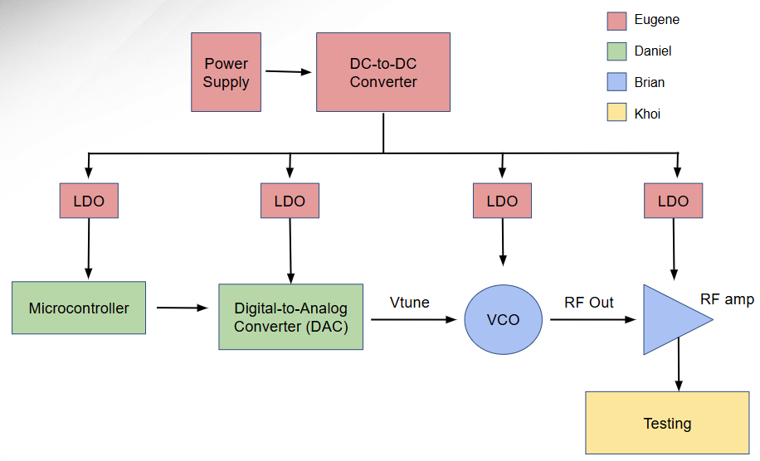

Figure 1. Sub-System Overview

# **Power Distribution Subsystem Report**

## ***Subsystem Introduction***

The power distribution subsystem is the distribution of power to the VCO, RF amplifier, and the microcontroller and making sure that the voltages and currents are at a stable with little noise.

## ***Subsystem Details***

### **System Function**

In this subsystem the main power supply that will be used for the entire waveform generator will be 2 AA batteries in series. The system has been separated into three different rails, digital for the microcontroller, VCO for the VCO and RF amplifier, and op amp for the microcontroller op amp. These will provide voltage and current to each specific part. Each rail consists of three steps which are the boost converter, an LDO, and a power monitor. Each rail has a boost converter to step up the battery supply voltage to a targeted value. The LDO that is used for the digital and VCO rails is to bring down the voltage while also lowering the noise that comes with stepping up the voltage. The op amp rail doesn’t have an LDO because the op amp is already designed for lowering noise. Lastly a power monitor is on each rail to measure the values. Table 1 shows the targeted values of each rail and the amount of voltage and current that will be used in an operation in greater detail. The figures below show how each rail is divided and the final product of the PCB design.

Table 1. Power Distribution Rail Breakdown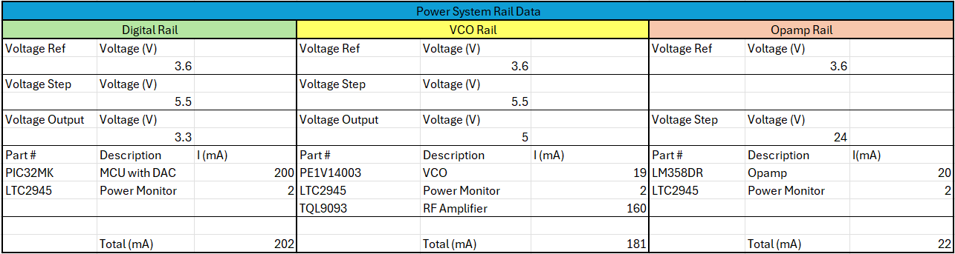

### **Schematics, PCB Layout, and Assembly**

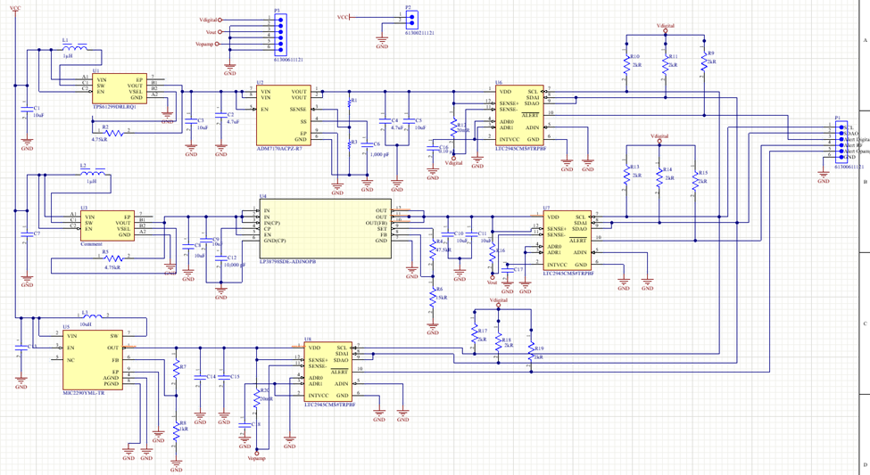Figure 2. Power Distribution Schematic

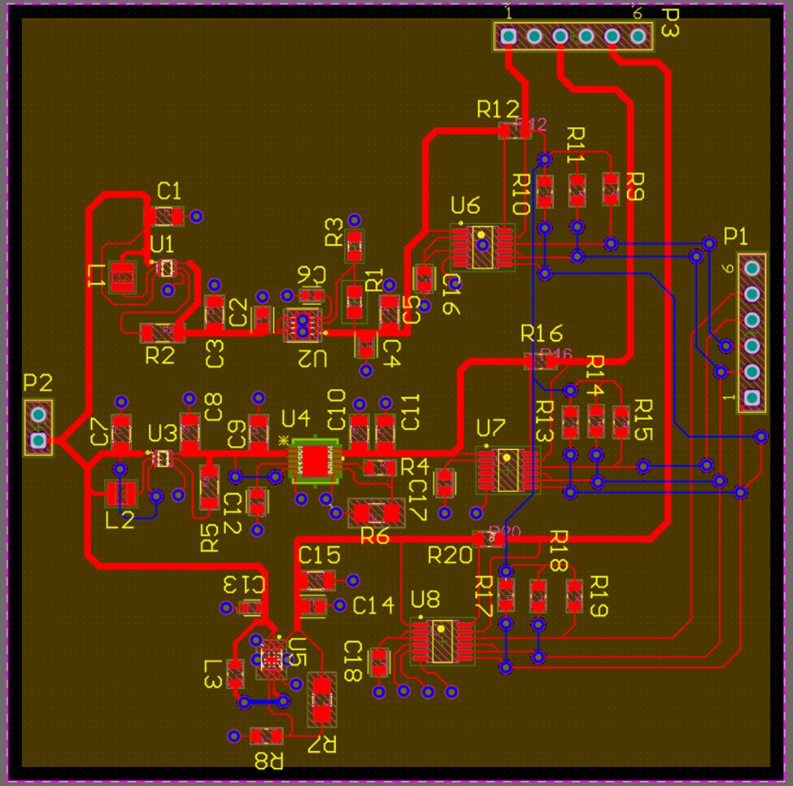

Figure 3. Power Distribution PCB Design Layout

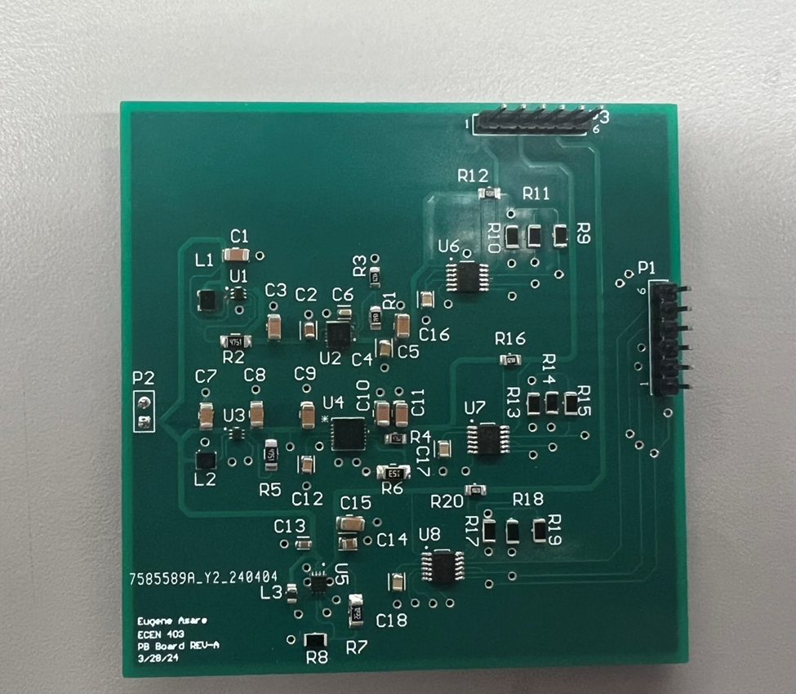Figure 4. Power Distribution Final PCB

## ***Subsystem Validation***

There were two main areas of testing for the power distribution subsystem. The first was to make sure that the correct voltage and current was being supplied at the end of the rail that would later feed into the specific parts during integration. To test the voltages and currents I used a multimeter and when the correct voltage was supplied switched to the battery supply and loaded with the other subsystems to see how much current was being used. The first few tests were very concerning with my rails but there was a huge error that I found and that was the boost converters for the Digital and VCO Rails were pinned incorrectly. Due to the error being caught late in testing the options I had to test the rest of the board were limited. I had to rewire the board in which the boost converters were not connected to the board. The results that are seen with the Digital and VCO rails are ones without the boost converters but just the LDO associated with them so complete validation with the initial board couldn’t be validated.

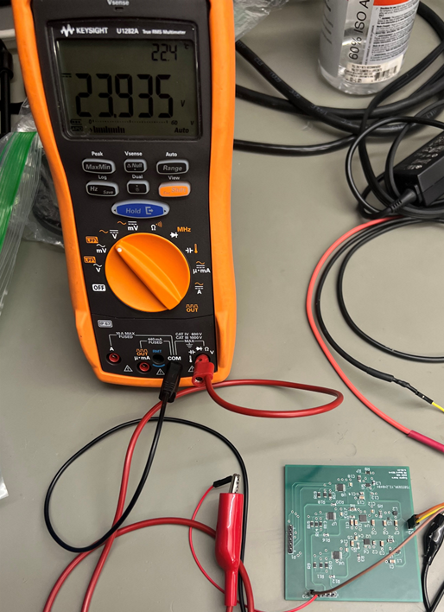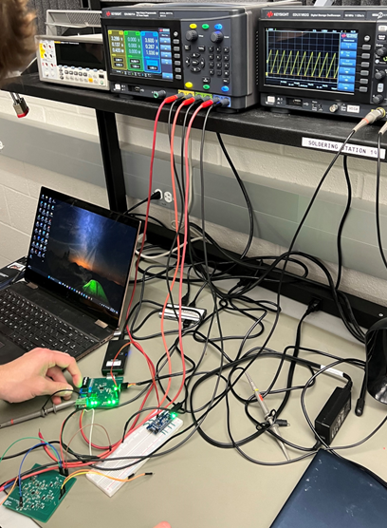

Figure 5. Op Amp Rail No Load Test Figure 6. Op Amp Rail with Load Test

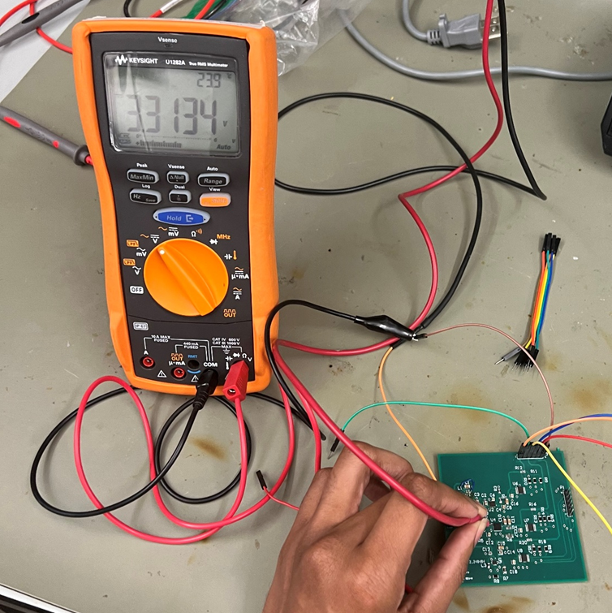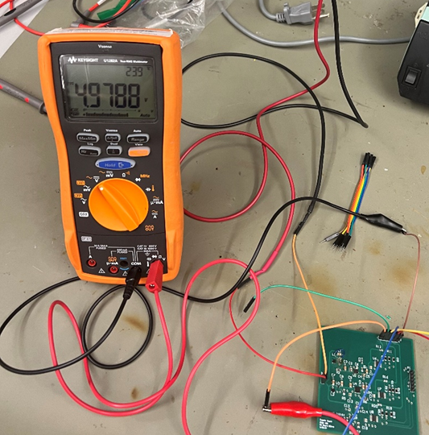Figure 7. Digital Rail LDO Test Figure 8. VCO Rail LDO Test

Table 2: Voltage Testing

| Test Number | Description | Measured Voltage (V) |
| --- | --- | --- |
| 1 | Digital rail | 0 |
| 2 | VCO Rail | 0 |
| 3 | Op Amp Rail | 23.950 |
| 4 | VCO Rail | 0 |
| 5 | Digital rail | 0 |
| 6 | VCO Rail | 0 |
| 7 | Digital rail | 0 |
| 8 | VCO Rail | 0 |
| 9 | Digital rail LDO | 5.435 |
| 10 | VCO Rail LDO | 5.134 |
| 11 | Digital rail LDO | 3.3134 |
| 12 | VCO Rail LDO | 4.9788 |
| 13 | Op Amp Rail | 23.935 |

The second test was to check if the power monitors were connected correctly within the rail and see if a signal was being pushed through. To validate this, I used an oscilloscope to measure the signals that the power monitor pins were giving out. The limitation of my subsystem is that I can’t test the specific addresses of each power monitor due to needing a microcontroller to process that data. The previous error affected the testing of the power monitors due to needing the digital rail voltage to be working properly. Once I corrected the error as best as possible, I was able to receive information for each of the power monitors and their respective pins.

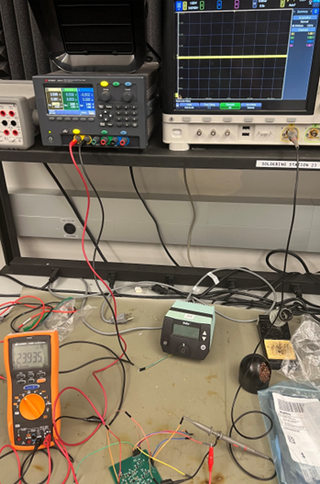

Figure 9. Power Monitor Signal Test

Table 3: Power Monitor Test

| Test Number | Description | Signal Measured (Yes/No) |
| --- | --- | --- |
| 1 | Op Amp Power Monitor | No |
| 2 | Op Amp Power Monitor | No |
| 3 | Op Amp Power Monitor | No |
| 4 | Digital Power Monitor | No |
| 5 | VCO Power Monitor | No |
| 6 | Op Amp Power Monitor | Yes |
| 7 | Digital Power Monitor | No |
| 8 | VCO Power Monitor | No |
| 9 | Op Amp Power Monitor | Yes |
| 10 | Digital Power Monitor | Yes |
| 11 | VCO Power Monitor | Yes |

## ***Subsystem Conclusion***

Overall, most of the components selected for distributing the power worked well. It was one major problem that I couldn’t see if the boost converters were working due to the pins being wired incorrectly on the PCB board. With this error I can’t confirm that it completely works but I was able to verify that the other components that are apart for the rail work correctly and the functionality will prove to be helpful.

*After debugging and testing in 404, this subsystem works properly. All voltages are outputting their required voltages of 3.3, 5, and 24. This means that the power subsystem is complete and ready to integrate*

# **Analog Drive Subsystem Report**

## ***Subsystem Introduction***

The Analog Drive Subsystem controls the Voltage-Controlled Oscillator (VCO) using a microcontroller to produce a voltage waveform. This subsystem is not only pivotal in achieving the main objective of controlling the VCO but also facilitates communication between the board and the Graphical User Interface (GUI). This communication is crucial as it enhances system monitoring, waveform control, and overall accessibility.

*After consultation with our sponsor, there were changes made to this subsystem and integration due to size constraints. Due to the removal of the GUI in 404, there is no communication via UART or I2C. Apart from this, everything has stayed the same*

## ***Subsystem Details***

### **System Function**

The Analog Drive Subsystem fulfills several key requirements. Firstly, it provides the analog drive or input voltage to the VCO, which can be adjusted via a hardware DIP switch offering seven distinct waveform states. These states include both modulation and constant frequency modes of the RF waveform. The second requirement is GUI communication through UART, allowing for software-based control of the system. The GUI may control the generator's state and perform error checking. The third requirement involves sensor communication via I2C to relay data necessary for system error checking. This data is transmitted from the MCU to the GUI through a UART connection.

The subsystem’s circuitry includes an analog drive PCB equipped with a DIP switch to control the state, multiple LEDs that indicate the system's current state, ports for programming and communication between the sensors and the GUI, and ultimately an output for the DAC signal. The operational flow is depicted in Figure 10, showing inputs from either the DIP switch or the GUI to the microcontroller. The MCU outputs the analog drive waveform from the DAC, which is then amplified by a non-inverting op-amp to meet the VCO’s voltage requirements. Concurrently, the MCU polls for voltage and current data from the power subsystem via I2C, which is forwarded to the GUI for analysis. The design was materialized into a PCB as illustrated in Figures 11-13.

*With the new changes of our system, the new requirements of this subsystem are to provide an analog drive voltage to the VCO, modulate this signal with a constant chirp rate, provide the user a way to control the state of the generator, and show the user what state the machine is in.*

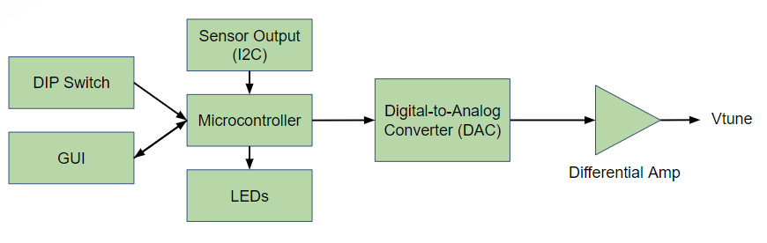

Figure 10. MCU Design

### **Schematics, PCB Layout, and Assembly**

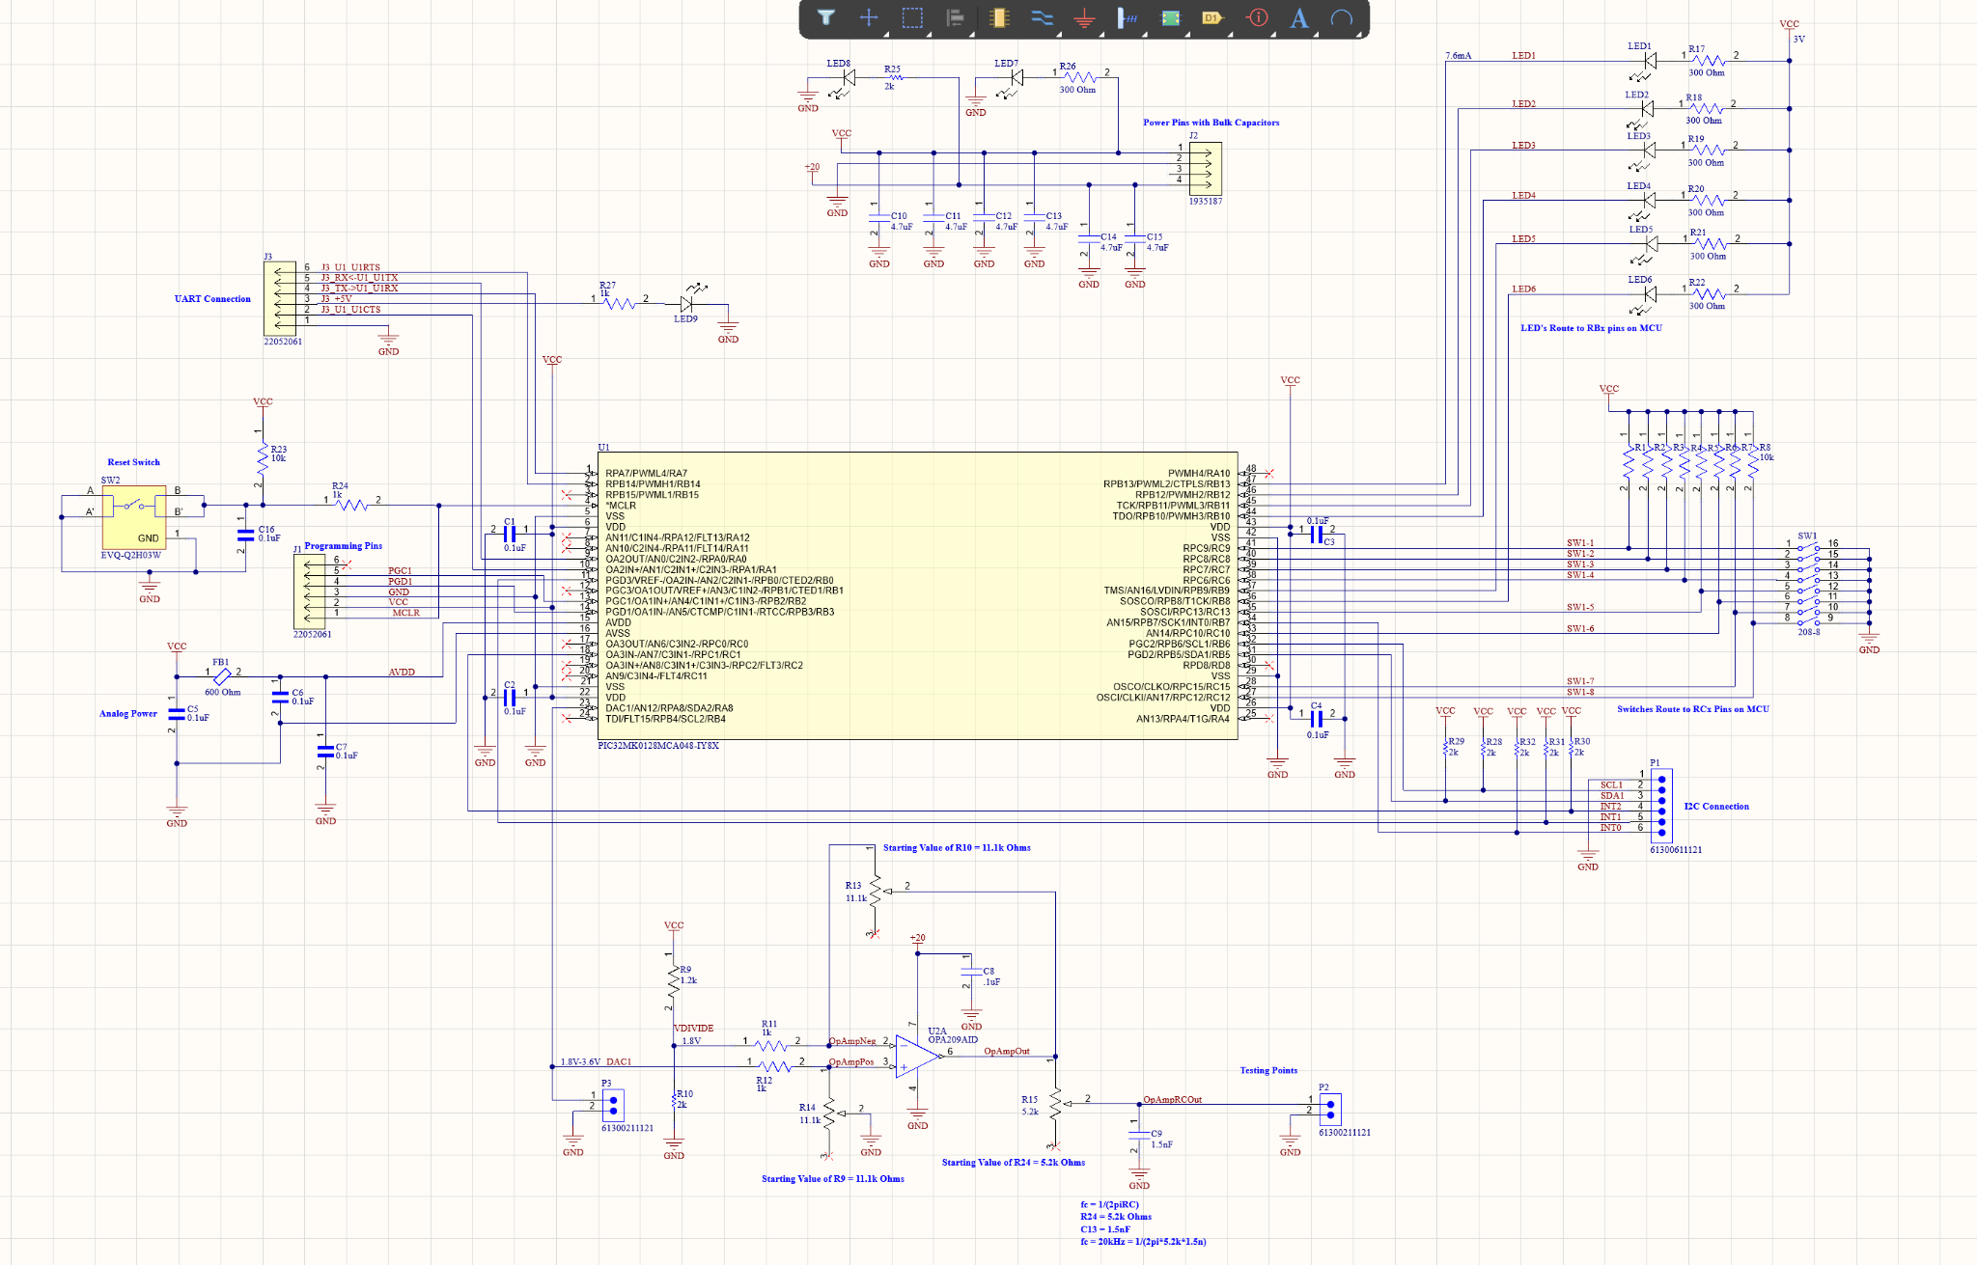

Figure 11. MCU Schematic

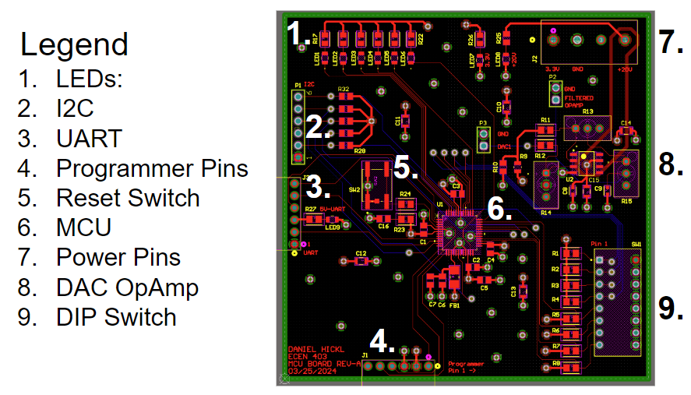

Figure 12. MCU Layout

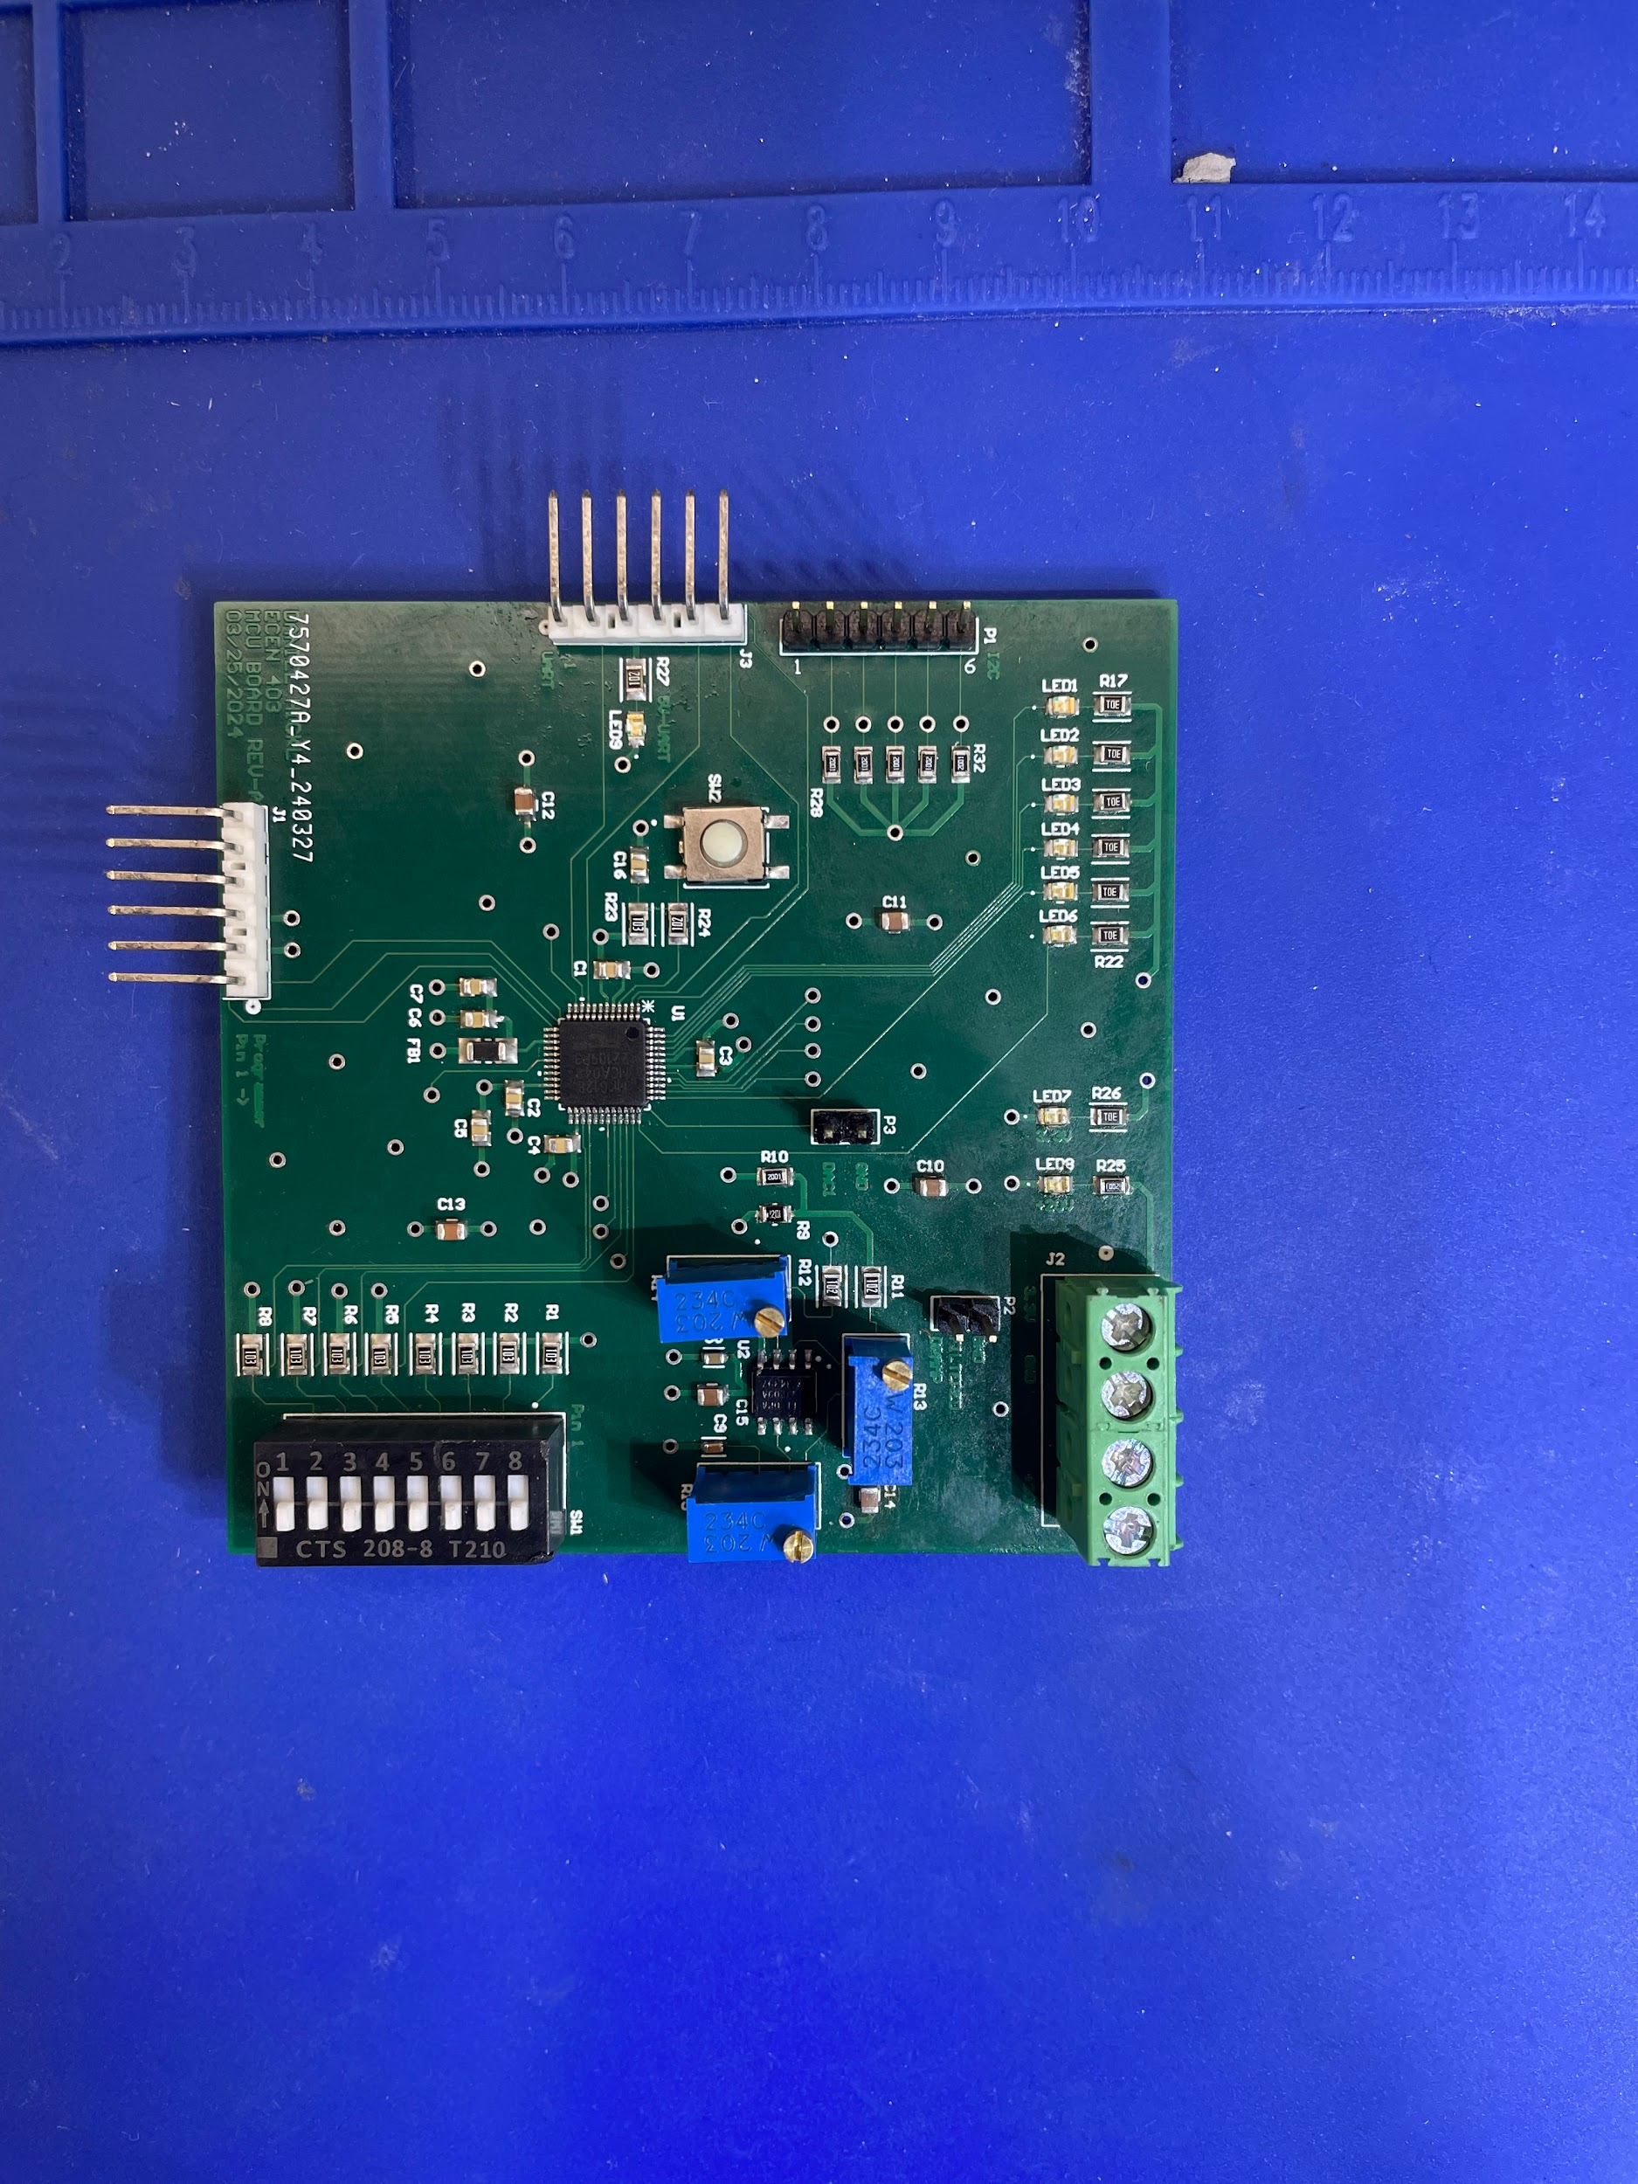

Figure 13. MCU Assembly

## ***Subsystem Validation***

### **Validation Overview**

There are two primary areas of testing for the microcontroller/analog drive subsystem: first is to test the MCU code, and second is to test the PCB itself. To test the MCU code, I used the PIC32MK evaluation board, which allowed me to flash code onto the chip and observe its outputs. This enabled the verification of the main functionality of my system, which included the DAC and the states of the generator. Additionally, I used two FTDI devices to assess the I2C and UART connections. To test the PCB itself, I utilized the same evaluation board code from earlier tests to flash onto the chip. This provided a consistent baseline for my testing, as any emerging errors could be attributed to the board rather than the code. I tested the seven states of the generator as shown in Tables 4-7 below, along with the UART and I2C connections.

### **Validation Tests**

* + - 1. *Constant Voltage Validation Test*

Table 4. Constant Voltage Mode Tests

| Constant Voltage Mode | | | | | |
| --- | --- | --- | --- | --- | --- |
| Test Number | 0V (V) | 5V (V) | 10V (V) | 15V (V) | 20V (V) |
| 1 | 0.09 | 4.98 | 10.03 | 15.04 | 19.89 |
| 2 | 0.09 | 4.98 | 10.06 | 15.02 | 19.95 |
| 3 | 0.09 | 5.01 | 9.94 | 15.02 | 19.95 |
| 4 | 0.10 | 5.00 | 10.00 | 15.02 | 19.96 |
| 5 | 0.09 | 5.00 | 10.02 | 15.01 | 19.96 |

* + - 1. *Constant Voltage Validation Test Analysis*

The constant voltage is used to create a constant RF frequency for our system. The tests in table 4 show the validation tests that were conducted to ensure the analog drive subsystem is fully functional for the constant voltage mode. Calibration through the potentiometers of my op amp needed to be done in order to increase the accuracy of these tests. Upon completion, this mode achieves an acceptable accuracy by being under a 0.5% error at the end of calibration.

* + - 1. *Modulation Validation Test*

Table 5. 1kHz Modulation Mode Tests

| Modulation Mode - 1kHz | | |
| --- | --- | --- |
| Test Number | Voltage (Peak to Peak) (V) | Frequency (kHz) |
| 1 | 20.50 | 0.92 |
| 2 | 19.90 | 0.96 |
| 3 | 20.00 | 1.01 |
| 4 | 20.10 | 1.01 |
| 5 | 20.00 | 1.00 |

Table 6. 5kHz Modulation Mode Tests

| Modulation Mode - 5kHz | | |
| --- | --- | --- |
| Test Number | Voltage (Peak to Peak) (V) | Frequency (kHz) |
| 1 | 17.90 | 4.96 |
| 2 | 17.90 | 4.96 |
| 3 | 17.90 | 5.06 |
| 4 | 17.90 | 5.05 |
| 5 | 17.90 | 5.03 |

Table 7. 10kHz Modulation Mode Tests

| Modulation Mode - 10kHz | | |
| --- | --- | --- |
| Test Number | Voltage (Peak to Peak) (V) | Frequency (kHz) |
| 1 | 15.90 | 9.48 |
| 2 | 15.90 | 9.76 |
| 3 | 15.90 | 9.90 |
| 4 | 15.90 | 10.16 |
| 5 | 15.90 | 10.05 |

* + - 1. *Modulation Validation Test* Analysis

The modulation mode is what is used to create an RF waveform with varying frequency for our system. The tests in tables 5-7 show the validation tests that were conducted to ensure the analog drive subsystem is fully functional for the modulation mode. Upon completion of these tests, one can see the degradation of the signal as the frequency of modulation increases. The peak to peak voltage of the signal is cut off and does not make it to 20V in the 10kHz and 5kHz tests. This can be explained due to an error in the choosing of my operational amplifier. The slew rate of my current operational amplifier is 6V/us. This is sufficient for the waveform as it increases, but it is insufficient as the waveform decreases. Since the sawtooth signal drops suddenly at the end of its period, the slew rate is much higher than 6V/us. This causes the signal to be clipped at its minimum which can be seen in figures 14-16 below. To fix this problem, I will order a new operational amplifier next semester with a slew rate of 20V/us

.

## sadfs

Figure 14. 1kHz Modulation Mode

## 

Figure 15. 5kHz Modulation Mode

## 

Figure 16. 10kHz Modulation Mode

*Upon testing in 404, changes needed to be made to the analog drive of the MCU subsystem. Due to the nonlinearity of the VCO, the output voltage frequency of the generator was not modulating at a constant rate. The solution to this problem was to fit the analog drive curve to match the input graph of the VCO in figure 33. This shows the frequency that matches each input voltage. Since the goal is to produce a sawtooth waveform in the frequency domain, each period must reflect this graph.*

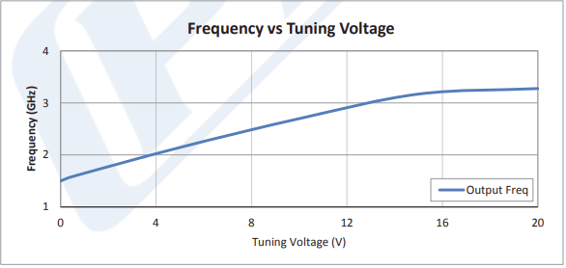

*Figure 38: Frequency vs. Tuning Voltage*

*To create this in the DAC signal, a piecewise defined function was used. Upon inspection of figure 33, there are two main sections of the graph. We approximated these to be linear sections and after doing so, the analog drive signal in figure 34 was produced. After testing, this was found to improve the linearity of the chirp rate.*

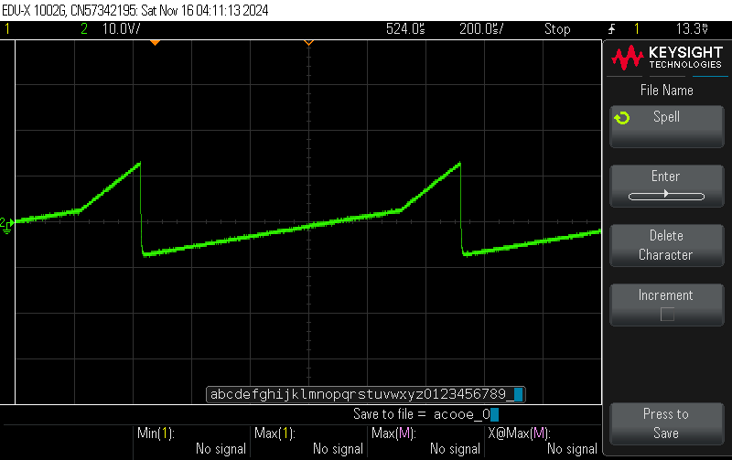

*Figure 39: New Analog Drive Signal*

* + - 1. *UART Connection Validation Test*

## 

Figure 17. UART Connection

* + - 1. *UART Connection Validation Test Analysis*

To test the UART connection, I used a program called SerialTool to send and receive data from my FTDI UART connector. I used this program to send values to my MCU which immediately responded by sending back the data. This proved the functionality of my UART connection.

* + - 1. *I2C Connection Validation Test*

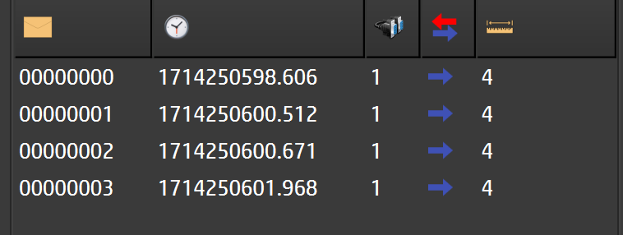

Figure 18. I2C Connection

* + - 1. *I2C Connection Validation Test Analysis*

To test the I2C connection, I used SerialTool to communicate between my computer and the MCU. My validation plan was to send data to the I2C connection on the MCU when prompted and then receive this data back when prompted. As one may see in figure 18 above, this connection was not functional. The reason for this was because I was not able to properly initialize the I2C testing board. I needed to buy another programmer to initialize this device as the slave. This error shall be fixed next semester during integration.

*Due to the rigorous size reduction of our generator, both the I2C and UART connections were removed from the final project. This decision was made with our sponsor due to the main goal of this project being low SWAP-C.These two communications were not necessary for our generator to function properly. The way of controlling the system is through the DIP Switch*

## ***Subsystem Conclusion***

Upon completion of validation testing, the analog drive subsystem functions well. The PCB works properly and has the ability to flash programs, output data, take inputs, and communicate via UART. The primary requirement, being the DAC output, works as expected barring a small hardware error with the operational amplifier. The UART connection is functional and awaits integration with the GUI. The I2C connection is non-functional, but upon integration, the MCU will directly probe the sensors in the power subsystem, eliminating the need for the connection board which is causing the error. The analog drive subsystem is ready for integration.

*In 404, the analog drive subsystem is completed and works properly. It meets the requirements of our new system.*

# **VCO/ RF Amplifier Subsystem Report**

## ***Subsystem Introduction***

The VCO and RF Amplifier subsystem is the heart of the RF Waveform Generator system. It takes a tuning voltage input from the Analog Drive subsystem and transforms it into a high-frequency signal in the RF domain. The primary components are the Voltage-Controlled Oscillator, which makes that transformation to RF, as well as the RF Amplifier, amplifying the RF signal so that it can be read and tested on a Spectrum Analyzer.

## ***Subsystem Details***

### **System Function**

In this subsystem, a tuning voltage from 0 to 20V is taken as an input for the VCO, which then produces an RF domain with a variable frequency dependent on the tuning voltage. That tuning voltage directly controls the frequency of the RF waveform, so increasing voltage increases the frequency. When the tuning voltage is sinusoidal, the resulting waveform contains a range of frequencies instead of just one since the tuning voltage is being swept across the bandwidth. From the VCO output, the RF amplifier then increases the magnitude of the frequencies for better visibility on the spectrum plot. All circuits surrounding it primarily serve as tuning for the amplifier. Figure # below represents the schematic of the subsystem design.

### **Schematics and PCB Design Layout**

| Figure 19. VCO and RF Amp Schematic | |
| --- | --- |
| Figure 20. VCO PCB Design Layout | Figure 21. VCO Final PCB |

## ***Subsystem Validation***

### **Validation Plan**

To test the subsystem, a DC Power Supply is used to provide the necessary supply voltage and current, as well as a Spectrum Analyzer to display the frequency at which the RF waveform is generated. The tests are categorized into two different modes, one for a fixed DC tuning voltage (on) and one for a sinusoidal tuning voltage (modulation). The DC tuning voltage tests are to ensure that the subsystem works before going into modulation mode. The table below represents the different tests used to validate the VCO and RF Amplifier Subsystem.

Table 8. VCO and RF Amp Validation Tests

| Mode | Tuning Voltage | Frequency | Description | Status |
| --- | --- | --- | --- | --- |
| On | 0 V | DC Input | RF waveform response at lowest tuning voltage | Completed |
| On | 10 V | DC Input | RF waveform response at mid-range tuning voltage | Completed |
| On | 13 V | DC Input | RF waveform response at highest tuning voltage | Completed |
| Modulation | 0-13 V | 1 kHz | Response to AC tuning voltage at 1kHz | Completed |
| Modulation | 0-13 V | 5 kHz | Response to AC tuning voltage at 5kHz | Completed |
| Modulation | 0-13V | 10 kHz | Response to AC tuning voltage at 10kHz | Completed |

One testing limitation to note is that the Spectrum Analyzer equipment provided at the school can only analyze waveforms up to 3GHz. Because this subsystem was originally meant to go from 1.6 GHz to 3.2 GHz, the range of the tuning voltage had to be narrowed to accommodate for the new bandwidth of 1.6 to 3 GHz. After some trials, 13V is the maximum tuning voltage in which the Spectrum Analyzer can still read (reaching 2.94 GHz in the results below).

### **Test Results**

* + - 1. DC Tuning Voltage Test Cases

| Figure 22. 0V DC Tuning Voltage | Figure 23. 10V DC Tuning Voltage |
| --- | --- |
| Figure 24. 13V DC Tuning Voltage | |

* + - 1. Modulated Tuning Voltage Test Cases

| Figure 25. 1kHz AC Tuning Voltage | Figure 26. 5kHz AC Tuning Voltage |
| --- | --- |
| Figure 27. 10kHz AC Tuning Voltage | |

### **Analysis and Observations**

Upon reading the spectrum analyzer plots above, the subsystem successfully works with a DC input voltage. While the 0V charts generates the a frequency of 1.53GHz instead of 1.6GHz, the waveform generator is intended to produce RF signals with a wide bandgap and is thus acceptable

As for the test cases with an AC, sinusoidal tuning voltage, the plot produces what looks like a series of impulse functions across a range of frequencies. This means that when the RF waveform generator is in modulation mode, the waveform should produce a multitude of frequencies which is what is seen on the spectrum plots. As the frequency of the tuning voltage increases, the number of frequencies in the RF waveform also increases making it look more like a step function. In general, these plots are synonymous with the expected results.



Figure 28. Spectrum Plot Flat Zone

However, one notable issue with the plot is that the range of frequencies doesn’t span all the way to 3GHz. Looking at the plot above, the range of frequencies zeros out (flat zone) between 2.27 Ghz and 2.7 Ghz, before resuming back again at the far right of the plots. This is likely due to the DC power supply not providing adequate voltages to the PCB during testing shown below. The voltage supply to the VCO reads 4.239V when it should be 5V, while to the amplifier it is 5.591V when it should be 7V. As a result, the system may not be properly operating at the entire range from 0-13V. This is an issue that will be addressed moving forward prior to system integration, but for the most part, the VCO and Rf Amplifier subsystems successfully works as intended.

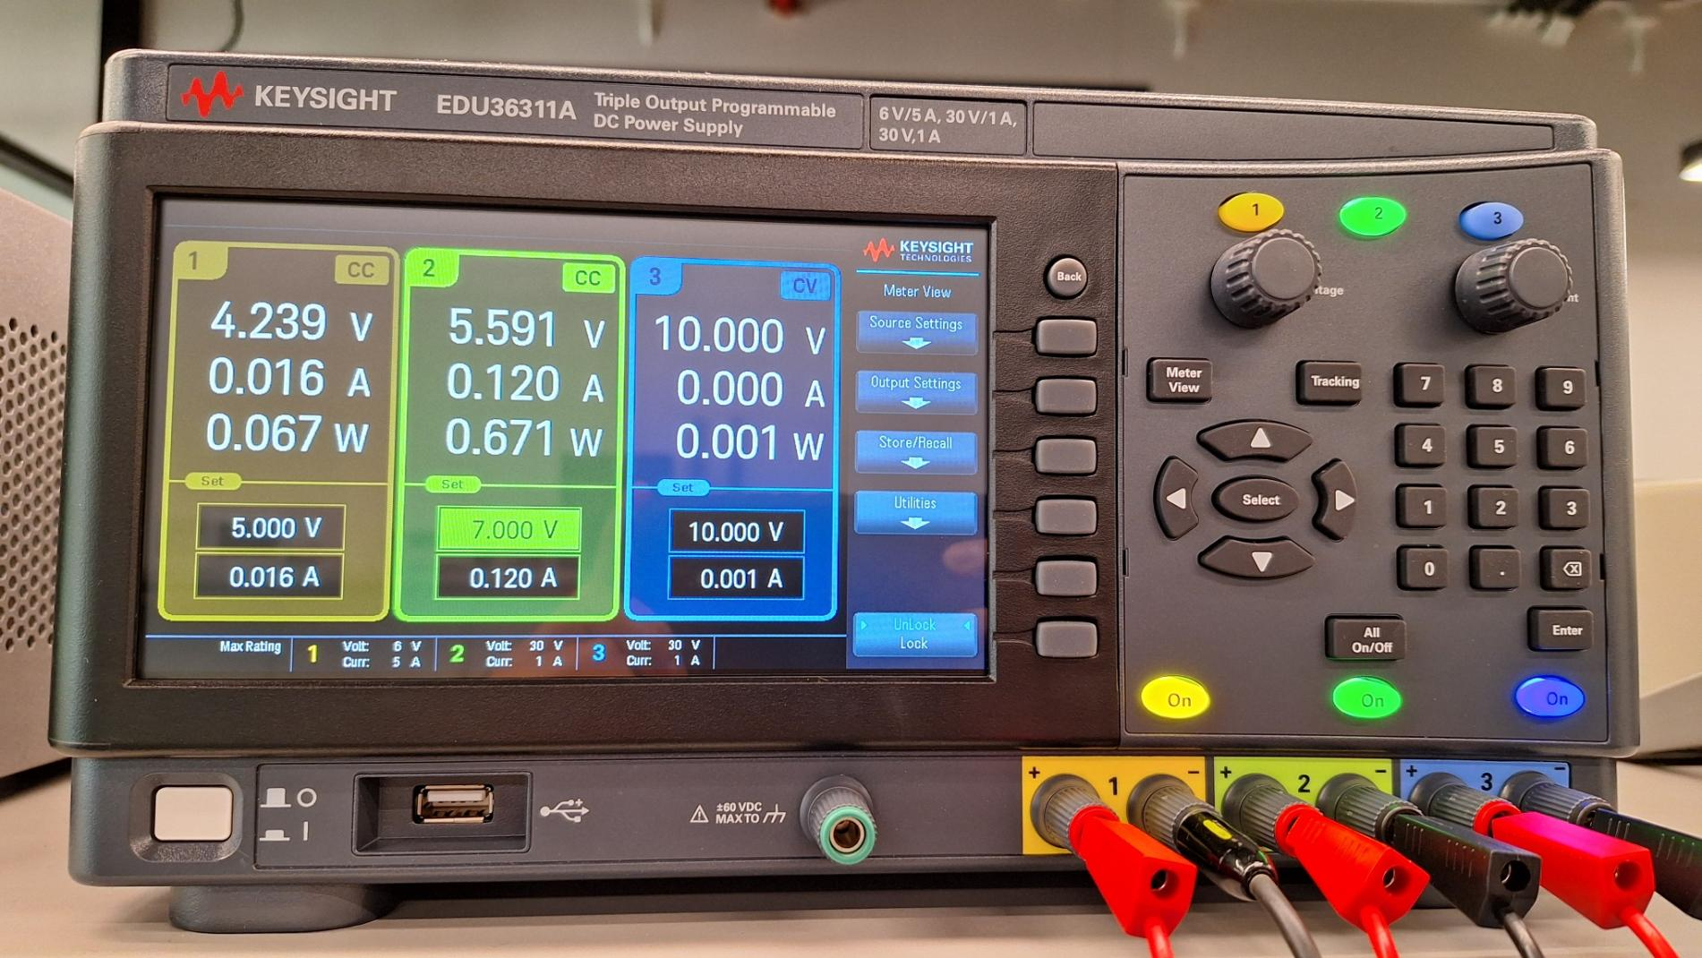

Figure 29. DC Power Supply Readings

*Upon testing in 404, these issues were resolved. The max frequency of the generator reached 3.2GHz.*

# **Testing Board Subsystem Report**

## ***Subsystem Introduction***

Due to the scope of RF, testing RF requires expensive equipment so we came up with an affordable testing approach using a mixer. Before we perform our testing methodology using pulse compression technique by the mixer, simulation of the technique in matlab is required to confirm our methodology and also compare the real result with the simulation. Furthermore, the subsystem proposed designing a low-cost mixer along with a low-SWAP RF.

## ***Subsystem Details***

* + 1. **System Function**

Beside modeling testing methodology, a low-cost mixer will be designed in this subsystem. The mixer performs frequency mixing by combining two input signals: an RF signal and a local oscillator (LO) signal. The output contains both the sum and difference frequencies of these signals, enabling the conversion of the RF signal to a different frequency domain, such as an intermediate frequency (IF) or baseband. Typically, the desired frequency component—usually the IF—is extracted through filtering at the mixer output. This is called an up-down convertion and this will be the main testing method.

* + 1. **Simulation Result**

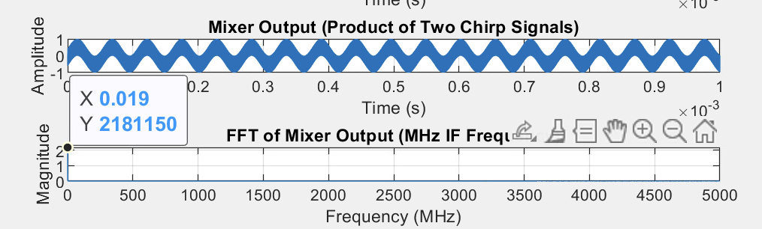

Figure 30. Simulation with 1KHz

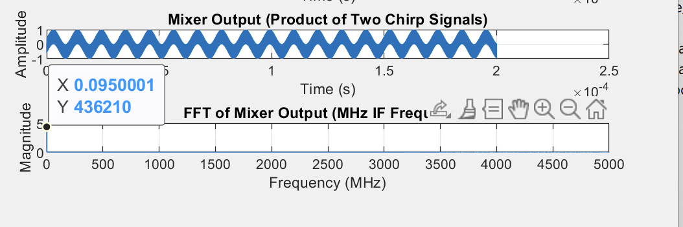

Figure 31. Simulation with 5kHz

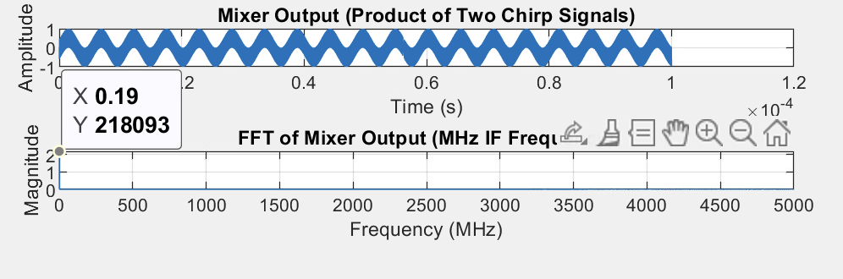

Figure 32. Simulation with 10KHz

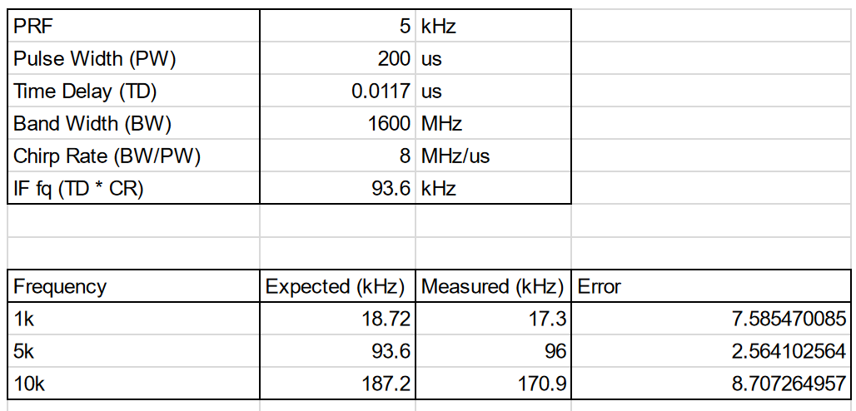

Table 9. Testing Result for Reference

* + 1. **Subsystem Schematic and PCB Layout**

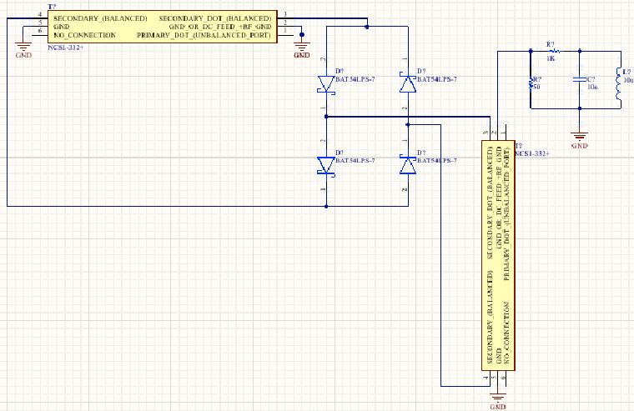

Figure 33. Schematic of mixer

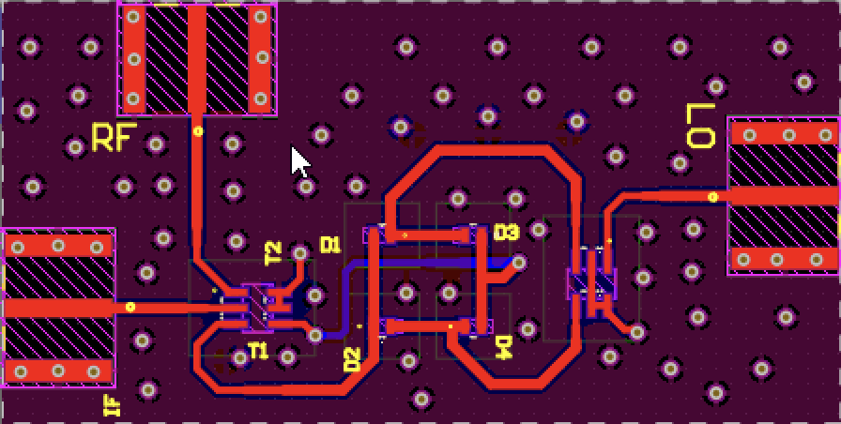

Figure 34. PCB Layout of Mixer

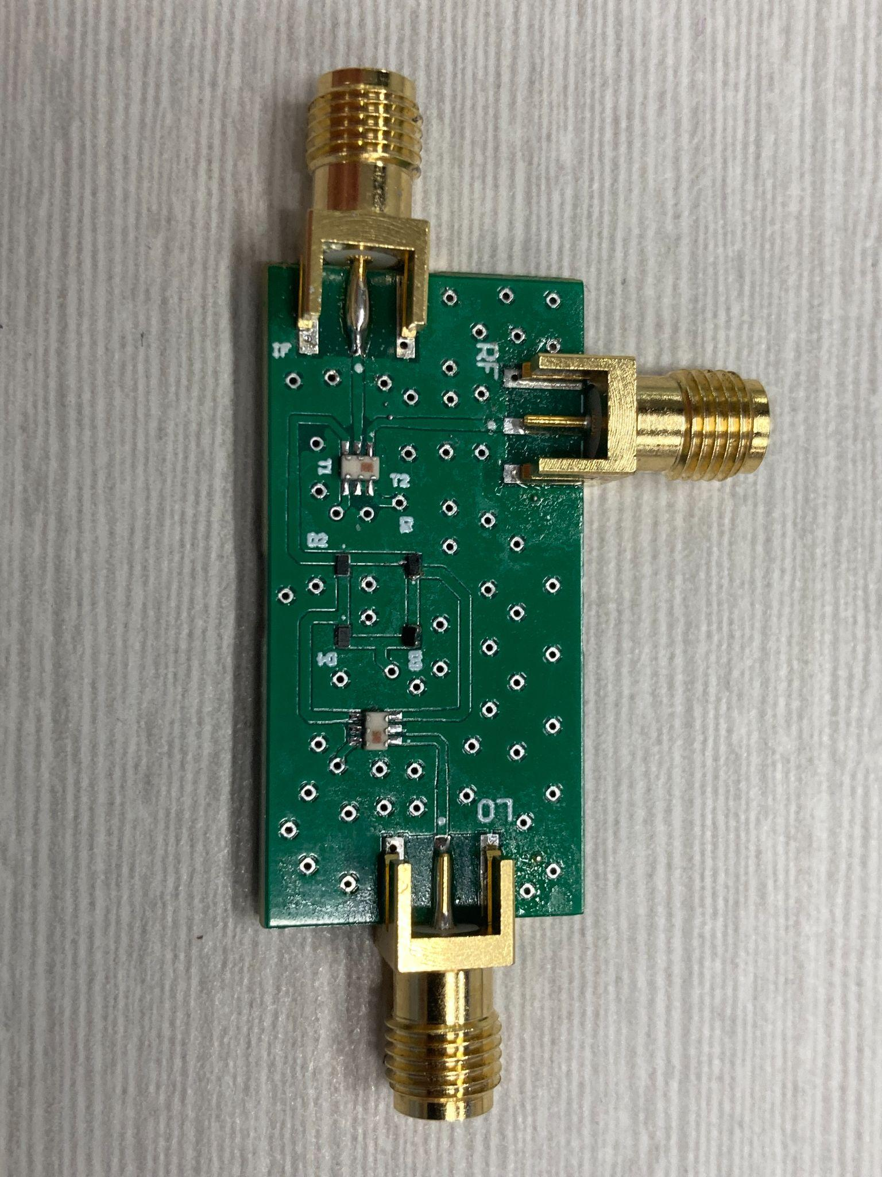

Figure 35. Mixer PCB

## ***Subsystem Validation***

* + 1. **Validation Plan**

To test the subsystem, a Signal Generator is used to provide both the RF input signal and the local oscillator (LO) signal as constant sine waves (up to 30MHz due to limitation of our lab equipment), while a Spectrum Analyzer is used to observe the output frequencies generated by the mixer. This testing mode verifies that the mixer correctly produces output containing both the sum and difference frequencies of the input signals.

| Testing MATLAB Code | Matlab code can simulate and visualize pulse compression given oscilloscope output | Generated input signal, do mixer operation then taking FFT and observe output signal | COMPLETED |
| --- | --- | --- | --- |
| Testing Circuit Simulation | Compared the Circuit Simulation output with the MATLAB output | Building mixer circuit with specific RF range, using Oscilloscope and Spec Analyzer in simulation to measure the waveform and frequency of output signal. | COMPLETED |
| Mixer Test | Mixer successfully fuses both reference and time-delayed signal to showcase frequency ramp | Use Oscilloscope and Spec Analyzer in lab to measure waveform and frequency output | COMPLETED |

Table 10. Validation Plan for Testing Board Subsystem

### **Testing Mixer Result**

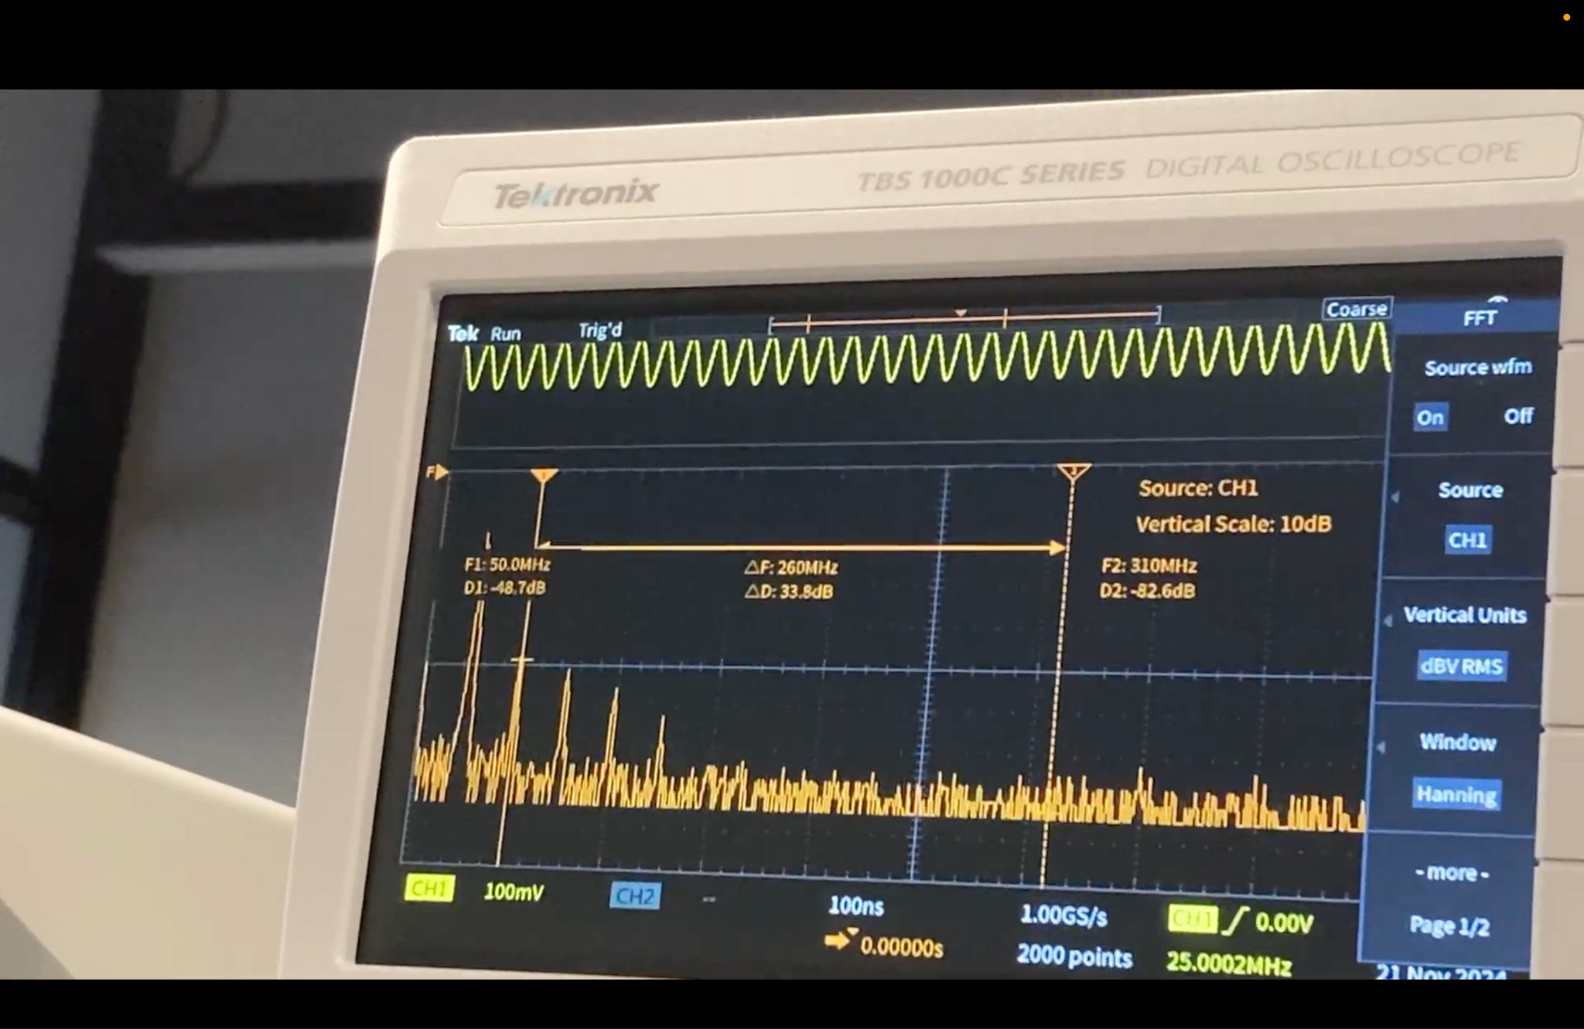

Figure 36. Testing with 25MHz

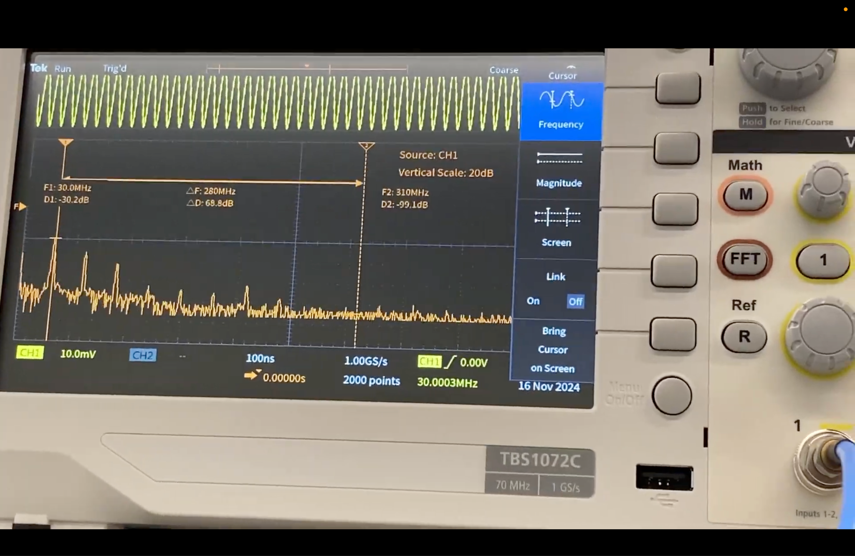

Figure 37. Testing with 30MHz

The mixer produced some expected IF outputs; for instance, when a 25 MHz LO and a 25 MHz RF signal were applied, a 50 MHz IF signal was observed on the oscilloscope. However, a harmonic frequency of 25 MHz also appeared in the spectrum. One possible explanation for this behavior is the use of low-quality components and the lack of consideration for trace length and spacing, which may have caused RF signals to couple and interfere, resulting in repeated self-mixing. Same for the testing with 30MHz.

# 

# 

# **Support Requirements**

Due to the nature of this project being R&D there is no technical support service or warranty that is needed.

# **Appendix A: Acronyms and Abbreviations**

RF Radio Frequency

GHz Gigahertz (1,000,000,000 Hz)

SWAP-C Size Weight and Power - Cost

R&D Research and Development

VCO Voltage-Controlled Oscillator

DAC Digital to Analog Converter

µC Microcontroller

GUI Graphical User Interface

LDO Low Dropout Regulator

PCB Printed Circuit Board

VDC Volts Direct Current

DIP Dual In-Line Package

USB Universal Service Bus

Op amp Operational Amplifier

MCU Microcontroller Unit

# **Appendix B: Definition of Terms**

| DC-DC Boost Converter | A device with a higher output voltage than input voltage. AKA a step-up converter because it “steps up” the voltage. |
| --- | --- |
| Digital to Analog Converter | A device that translates digitally stored information from a computer or phone into an analog sound that we can hear. |
| DIP Switch | Consists of a small block of switches mounted on a dual in-line package. Each switch corresponds to a specific binary digit. Using the switch on the PCB provides flexibility in configuration. |
| Graphical User Interface | A type of user interface that allows users to interact with a device or software via graphical components such as buttons, menus, windows, or text-based interfaces. |
| Low Dropout Regulator | A device that takes an input voltage from a power supply and uses that input to output a steady voltage. |
| Voltage-Controlled Oscillator | An RF oscillator circuit whose frequency can be controlled by a DC input voltage. |